Design changes:
Change Background colour to - #FEF8FF 
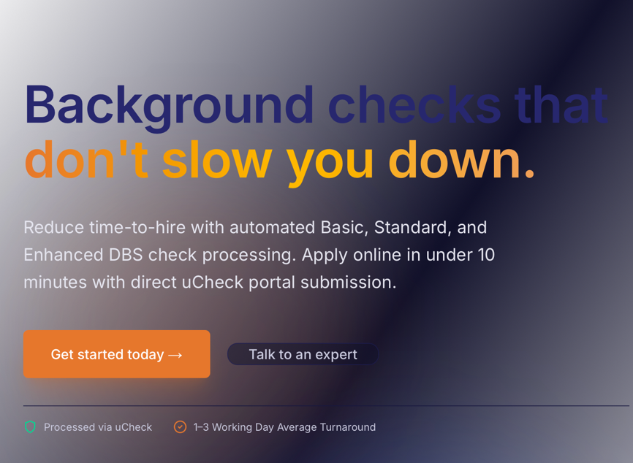
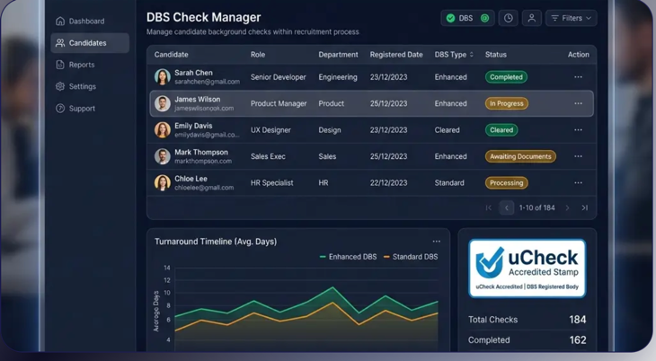 <<edit this image to the below template
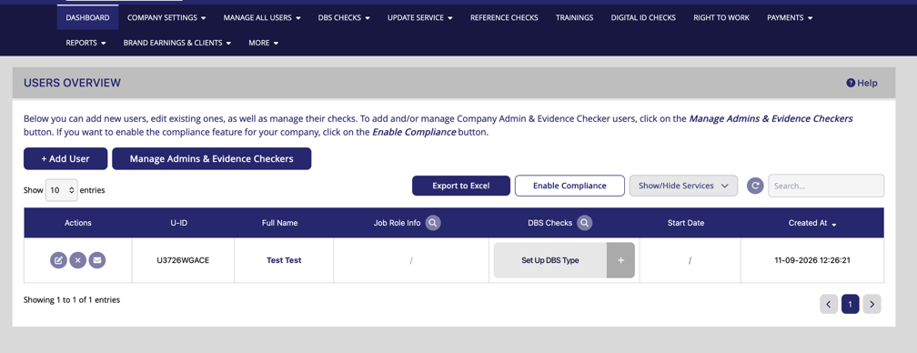 on this image edit and include whatever you like that’s appealing (example names etc)
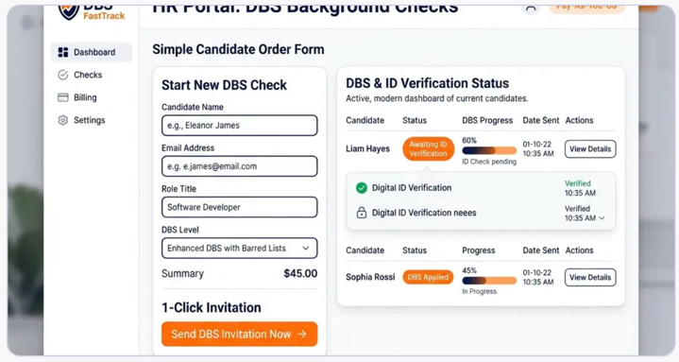change photo to one of the below -
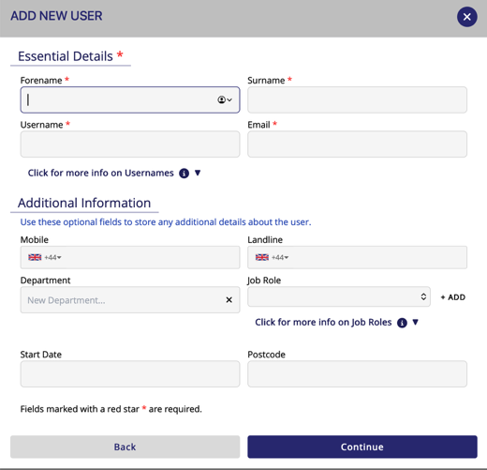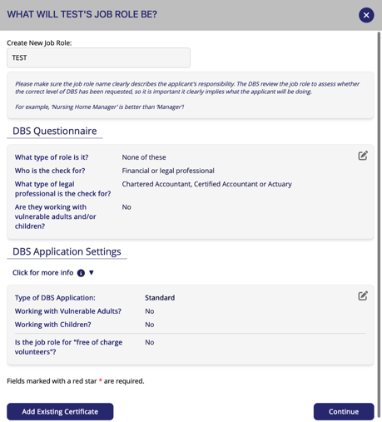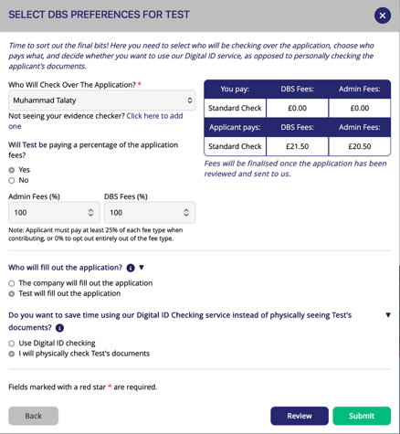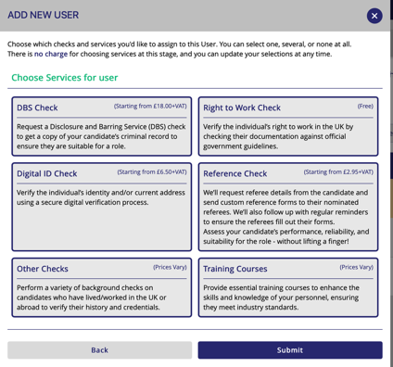

remove these two options below

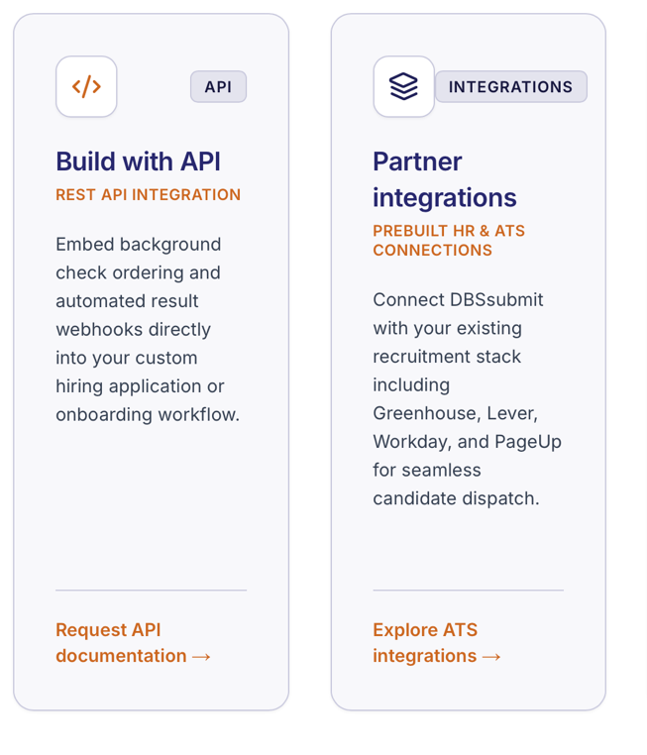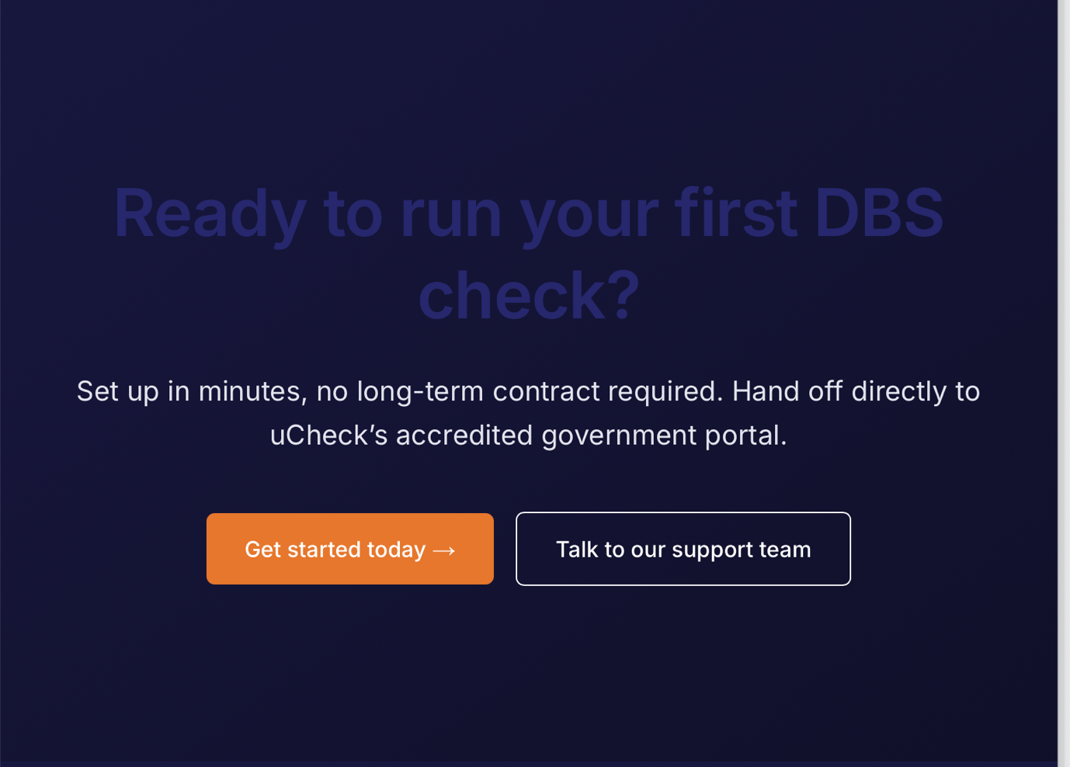change background colour to - #FEF8FF

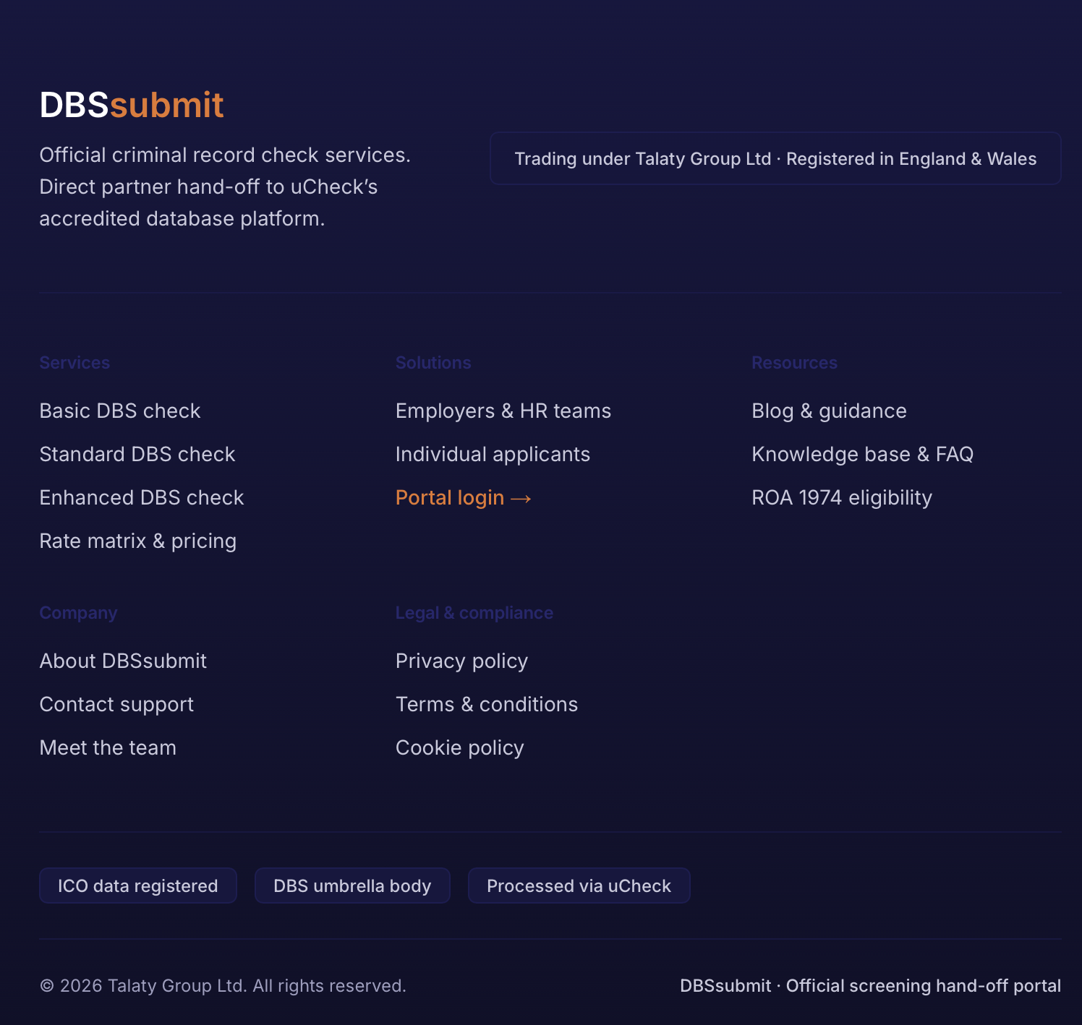change this background colour to grey so all the writing is more readable.

Wording –
Anything that says along the lines of ‘Ucheck’ needs to change to ‘Aarons Department’
Turnaround times –
Basic – under 24 hours – 48 hours
Standard – 1-5 days
Enhanced – 6-13 days
Also there is same day processing for submissions made before 4pm UK time.

Employers page –
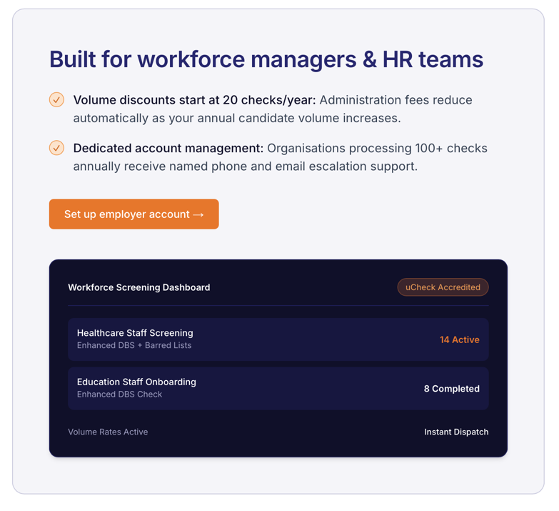volume discounts start at 51+ checks, also. All organisations receive the same level of support.
Use this dashboard image -

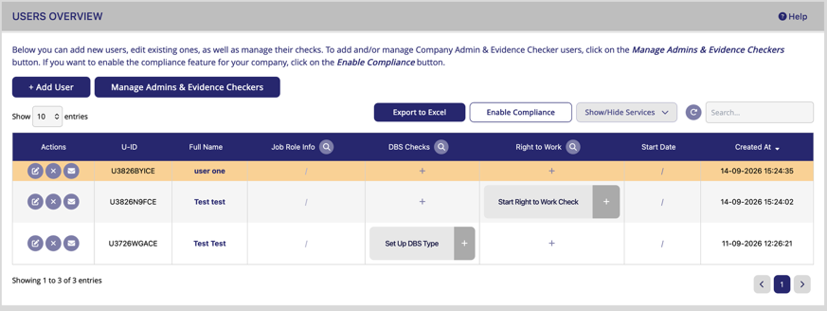

Pricing – Business / individual pricing
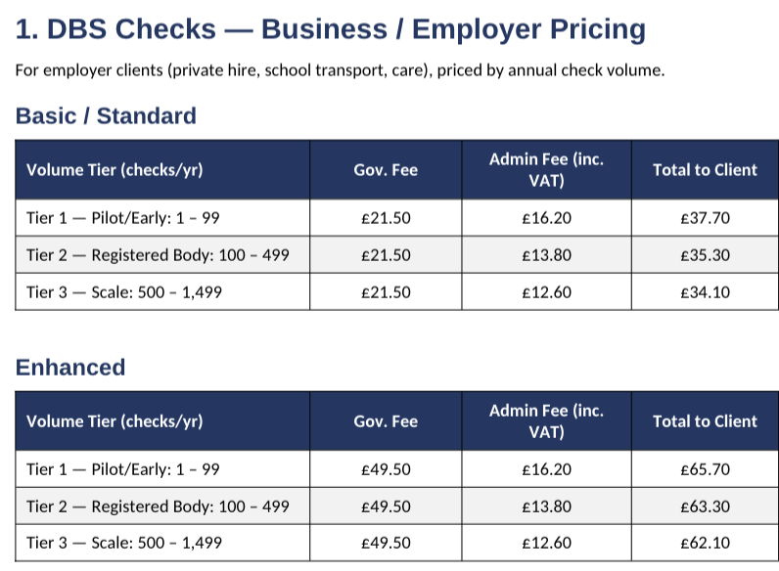

Individual pricing 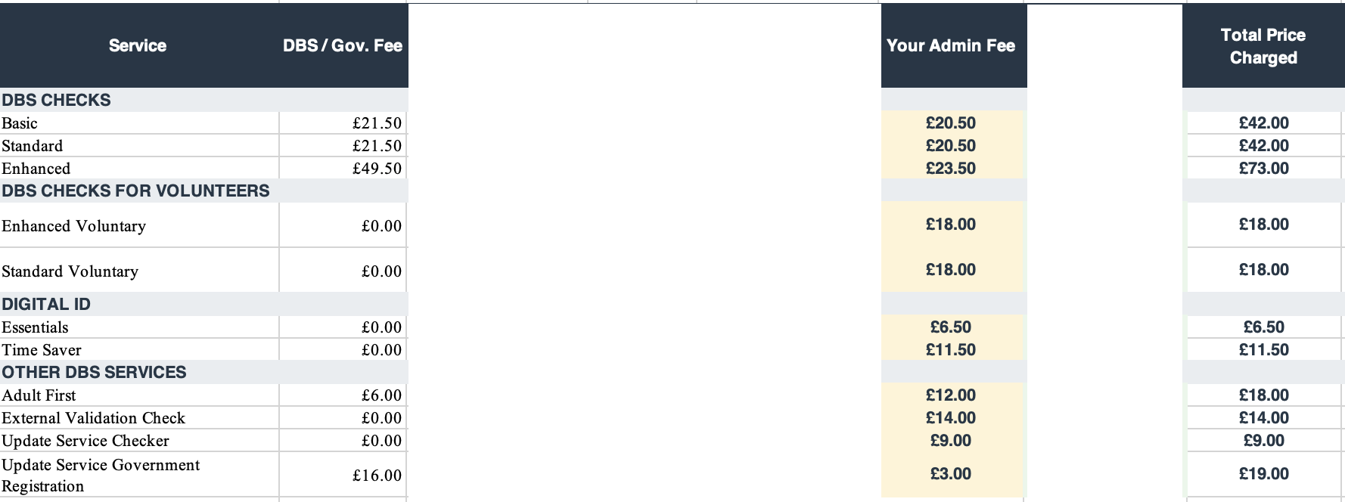

About page –
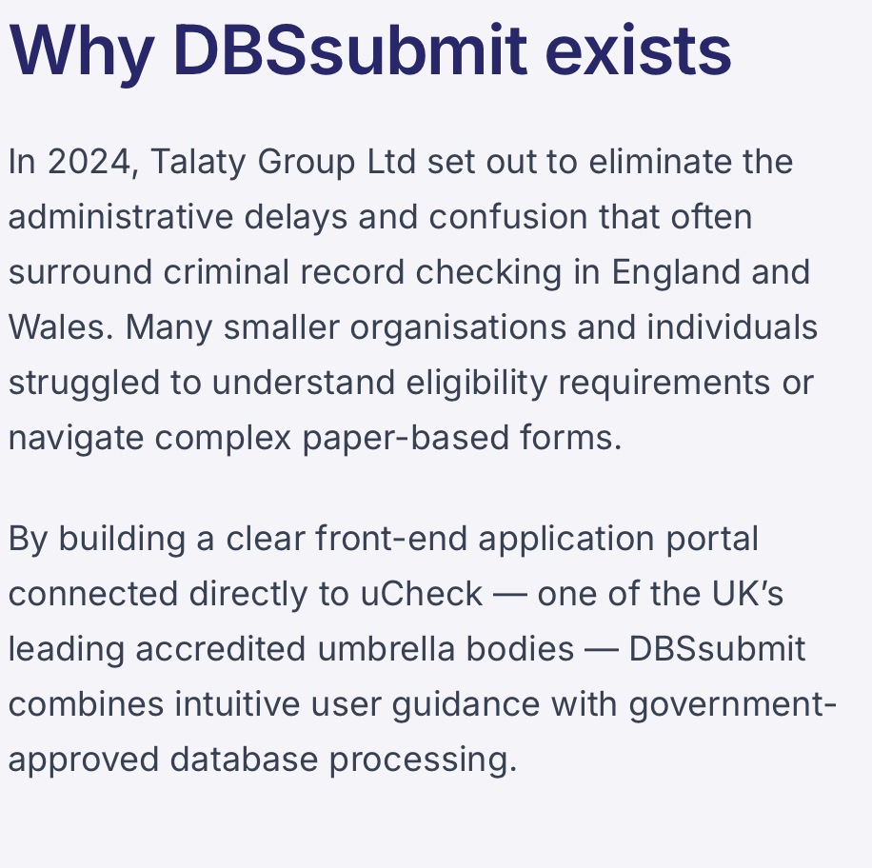 remove in 2024. Start the sentence with ‘Talaty group set out….
Remove the Ucheck part.
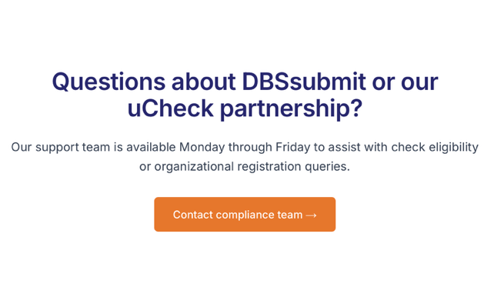
change the title to ‘questions about DBS-Express?

Overall –
Change all language used to UK English, remove anything to do with UCheck.
Change footer colour to the advised colours requested previously in document.

URL Links that have been provided to me from the provider:
Client Registration Page:https://www.dbs-express.co.uk/app/ci/index_controller/sign_up
Log In Page: https://www.dbs-express.co.uk/app/login_direct
Telephone: 01254 432655
Email: contact@dbs-express.co.uk

